Discovering Tutankhamun Family Trail
24th July – 2nd November 2014

Gallery 58 - The search for Tutankhamun
Howard Carter started excavating in the Valley of the Kings in 1917.
Five years later in 1922 he found the tomb of Tutankhamun.
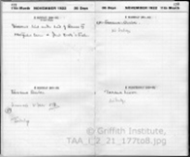
Find this object:

It is open at the page showing the entry for 5th November 1922.
Read what Howard Carter wrote about the day's events.
How do you think Howard Carter felt when he was writing this?

Look around at the other objects and photographs on display and find something:
signed and dated by Howard Carter
found in the Valley of the Kings

Gallery 61 – Recording the Tomb
The tomb of Tutankhamun was discovered on 4th November 1922.
Carter and his team spent 10 years recording and removing all the objects in the tomb.
They created over 15,000 documents which are now held by the Griffith Institute, Oxford.
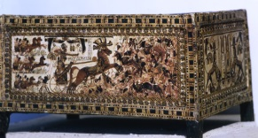
Find this object:

This is a reconstruction of one of the boxes from the tomb.
It is known as Box 21 or the ‘Painted Box’ and it was the first object Howard Carter
removed from the tomb. Can you spot Tutankhamun riding in his chariot?

Look around at the other objects and photographs on display and find something:
which shows the team who excavated the tomb
showing a place to clean and conserve objects

Gallery 60 – Tutmania
The discovery of the tomb was reported all over the world.
Objects from the tomb influenced fashion, films and everyday objects in the 1920s.
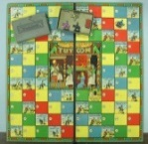
Find this object:

This is a board game inspired by the discovery of Tutankhamun’s tomb.
To win your donkey must reach the tomb first. But watch out for the snakes!

Look around at the objects and photographs on display and find something which:
told people about the discovery of Tutankhamun's tomb
plays a song about Tutankhamun

Gallery 59 - Interpreting Tutankhamun
In 2014 it will be 91 years since the tomb of Tutankhamun was discovered.
Only 30% of the objects from the tomb have been written about in detail.
The original excavation records held at the Griffith Institute in Oxford are an important source of information used by many people around the world.
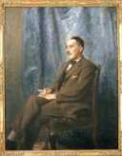
Find this object:

This portrait of Howard Carter was painted by his brother William Carter.
It was painted from photographs and memory because Howard did not like sitting still.

Look around at the objects and photographs on display and find something which:
shows the decoration on the tomb walls
is a copy of something found on Tutankhamun’s mummy

If you’ve enjoyed the exhibition and would like to learn more about Tutankhamun please visit our web site: http://www.griffith.ox.ac.uk/learning

